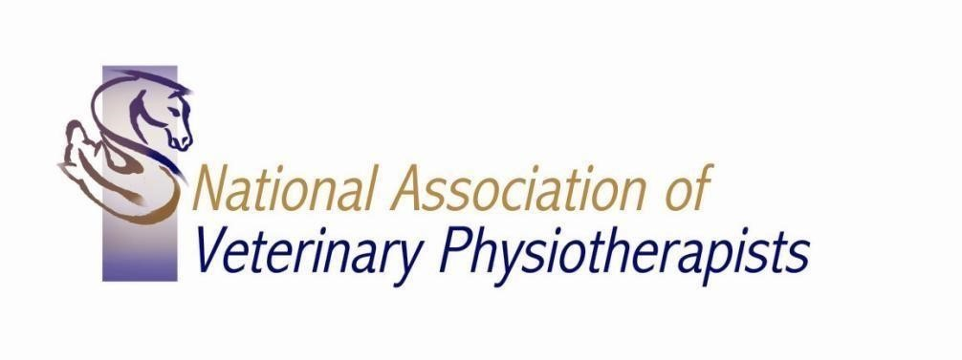
Conditions of Membership of NAVP 2020/21

- Payment of Membership fees must be made to the Treasurer by March 1st of each year. Members will be sent invoices and reminders.
- Payment of fees, proof of insurance and CPD entitles members to be listed on the NAVP website under geographical area and to have access to the Members only page.
- Members may use the NAVP logo (see Conditions of use of logo below) and may use the post nominals MNAVP as soon as they receive notification that their application has been successful.
- CPD is a requirement of Membership. The required number of CPD points is 50 credits over 24 months. CPD will be checked in an annual random audit.
The CPD activity sheet must be completed and sent in with the renewal application.

- Members must carry insurance and copies of their insurance certificates must be submitted. Minimum indemnity must be £2,000,000. If you are working for a veterinary practice and are covered by their insurance please provided the following statement with your application - signed and dated.

‘I …………………. am solely working for …(insert vets name)… vets treating their clients and am covered by their insurance policy. I fully understand that I am not covered to treat my own private clients unless I take out my own insurance policy. I understand I must inform NAVP of any changes to my work situation.

Signed…………………………………………………… Date………………………………………….’

- Members must agree to abide by the Code of Conduct.

- Members who take time out of practice may cancel their insurance and fill in the Return to Practice form (available from Laura Stevens navpsec@yahoo.co.uk ). CPD and membership fees will still apply during time off work.

- Copies of the Code of Conduct, Disciplinary procedures and logo can be obtained from the Secretary. All new members will be sent a copy of each in their welcome pack.
- New members are entitled to attend the yearly AGM but will have no voting rights until after their first 12 months of membership.

- Members must attend at least one AGM in three.

Part of the work of the association is to help keep high standards of professionalism which make our members instantly recognizable to the veterinarians and owners.

- Placement Providers: Members may only become Placement Providers after 2 years in practice and must have completed the NAVP Accredited Clinical Educators course (or similar).
Approved Placement Providers are listed by NAVP and this list made available to all education providers.

- Clinical Tutoring: Members may be asked by education providers to help tutor on clinical teaching sessions. They can help tutor after 1 year in practice provided, they will be supervised by a senior veterinary physiotherapist, but also should have completed the NAVP Accredited Clinical Educators course or hold a teaching certificate.

- In your first year in practice (your graduate year) you will need to submit 2 case histories which you have been treating – this allows us to mentor new graduates. At the end of your first year you can choose one of your cases to present to your colleagues.

These case presentations are not an exam or a test, they simply allow us to help and discuss with you how you are doing in your first year. Previous graduates have enjoyed meeting up with their colleagues, presenting and discussing their case.

If you have registered with the AHPR you will have to do a Professional Development Portfolio (PDP) as a new registrant, in which case you will not need to do the 2 case histories for NAVP.

The final presentations will be delivered either at face to face meetings or via Zoom – depending on the COVID-19 situation.

Use of the NAVP logo.

  - Members may use the trademarked NAVP logo (the graphic + the initials NAVP) on their professional stationery only in the colours in which it is registered.
  - Members may use the graphic and the full wording ‘National Association of Veterinary Physiotherapists’ on their professional stationery in the colours we trademarked.
  - Use of the logo, the initials NAVP or the title National Association of Veterinary Physiotherapists in any capacity other than on professional stationery must have the approval of the Executive.
  - Members are not allowed to permit or grant consent to anyone else to use the NAVP logo.

